**Modelling and Simulation of a DC Motor Drive**

# 1.DC Motor Model

## 1.1 Dynamic Equations

First, a simulation model of the permanent-magnet DC motor will be built. The following state equations are taken as a starting point:

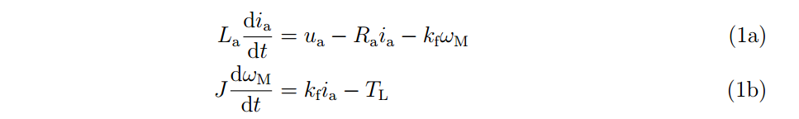

## 1.2 Building the Model

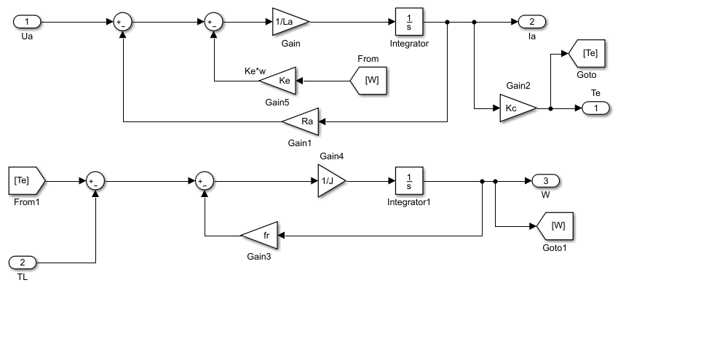

# 3 DC-DC Converter and Unipolar PWM

Ua = (*q*A*−q*B)*U*dc

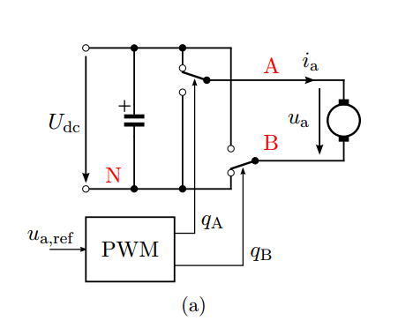

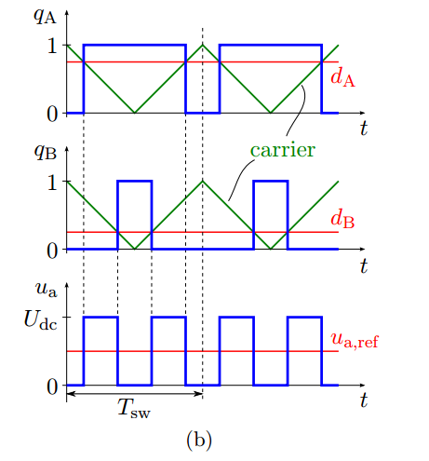





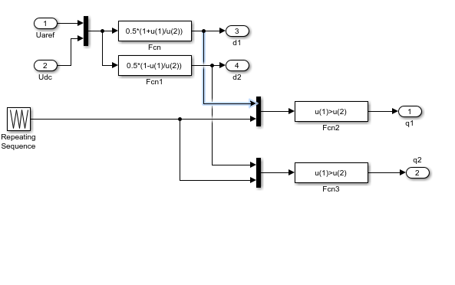

Simulink implementation of unipolar PWM.

# Control

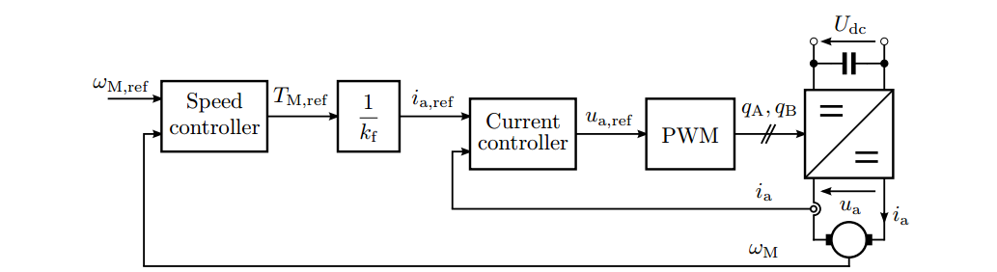

control system of the DC motor

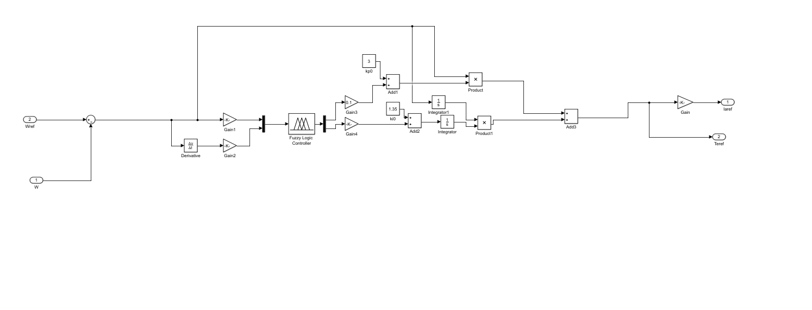 Speed Controler of the DC motor With Fuzzy